1. Find the date of next Sunday.

🡺 select next_day(sysdate,'sunday') from dual;

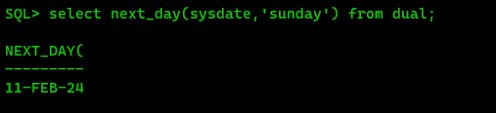

1. Find 7 raised to the power 7.

🡺select power(7,7) from dual;

1. Input your name(first_name last_name) in upper case “JAYANTA MONDAL”. The output should come under the alias MY_NAME and the name should appear in lower_case but the first letter of first_name and last_name should be in upper_case.

è SELECT INITCAP('JAYANTA MONDAL') AS NAME FROM DUAL;

1. Create and insert the following:       STUDENT12

|  |  |  |  |
| --- | --- | --- | --- |
| Roll_No | Name | CGPA | DOB |
| 120 | Avi | 6.55 | 09-Jan-2000 |
| 134 | Beena | 8.20 | 31-Aug-2002 |
| 155 | Charu | 8.20 | 23-Dec-1999 |
| 202 | Dawar | 9.15 | 09-Jan-2000 |

🡺 CREATE TABLE student12 ( roll_no number, name varchar(10), cgpa number, dob date );



INSERT INTO student12 VALUES (&roll_no, '&name', &cpga, '&dob')

1. Say, stipend is given to all students. 10000 if cgpa>9, 7000 if cgpa>8, 5000 if cgpa>7, rest are given 1000 rupees. List the students name and stipend received by them.

🡺 select Roll_no,name,CGPA,decode(trunc(CGPA,0),9,10000,8,7000,7,5000,1000) as stipend from student12;

1. Show the students name in upper_case, and DOB in the following format : five-february-two thousand twenty-four.

è select upper(name), to_char(dob,'ddsp-month-yyyysp') dob from student12;

1. Count the number of students present in the student12 table.

🡺 SQL> select count(*) as student_count from student12;

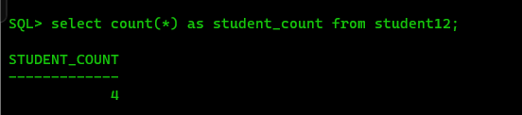

1. Select the average age of the students.

🡺 SELECT AVG(EXTRACT(YEAR FROM SYSDATE) - EXTRACT(YEAR FROM DOB)) as average_age FROM student12;

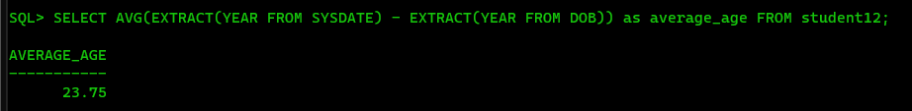

1. Make the set of name,cgpa and DOB, the primary key of the student12 table.

🡺 ALTER TABLE student12 ADD CONSTRAINT pk_student12 PRIMARY KEY (name, cgpa, DOB);



1. Make roll_no the new primary key of the table.

🡺 ALTER TABLE student12 DROP CONSTRAINT pk_student12;

ALTER TABLE student12 ADD CONSTRAINT pk_student12 PRIMARY KEY (roll_no);

